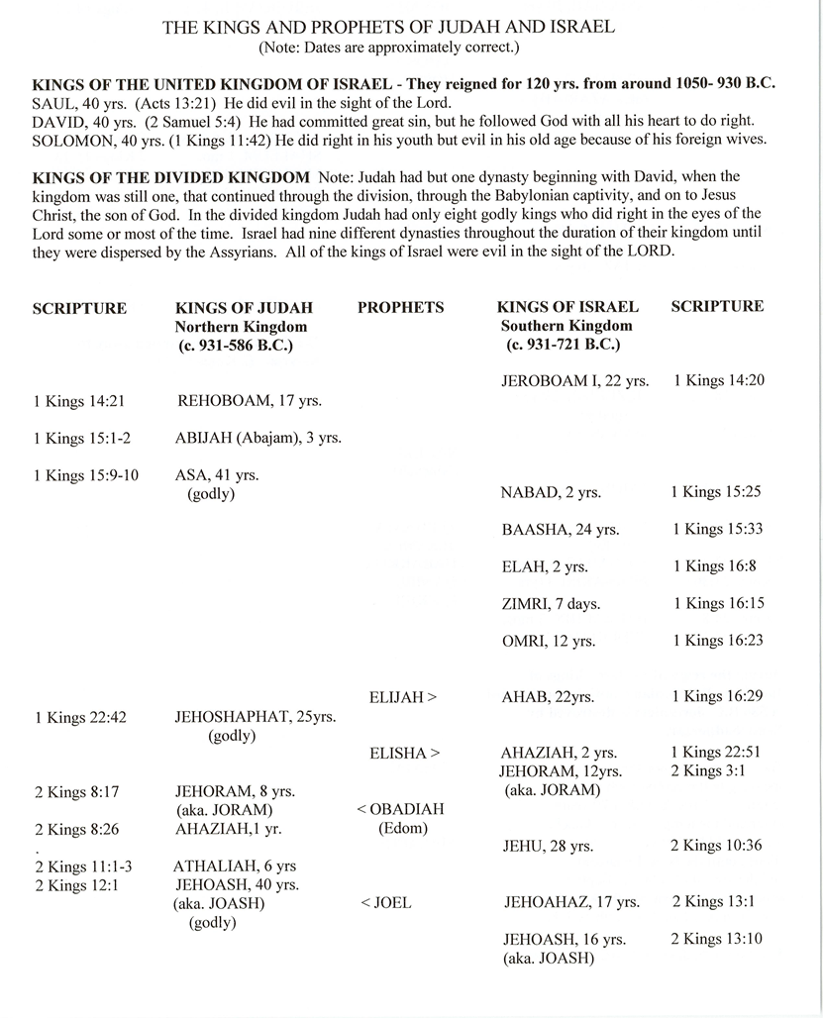

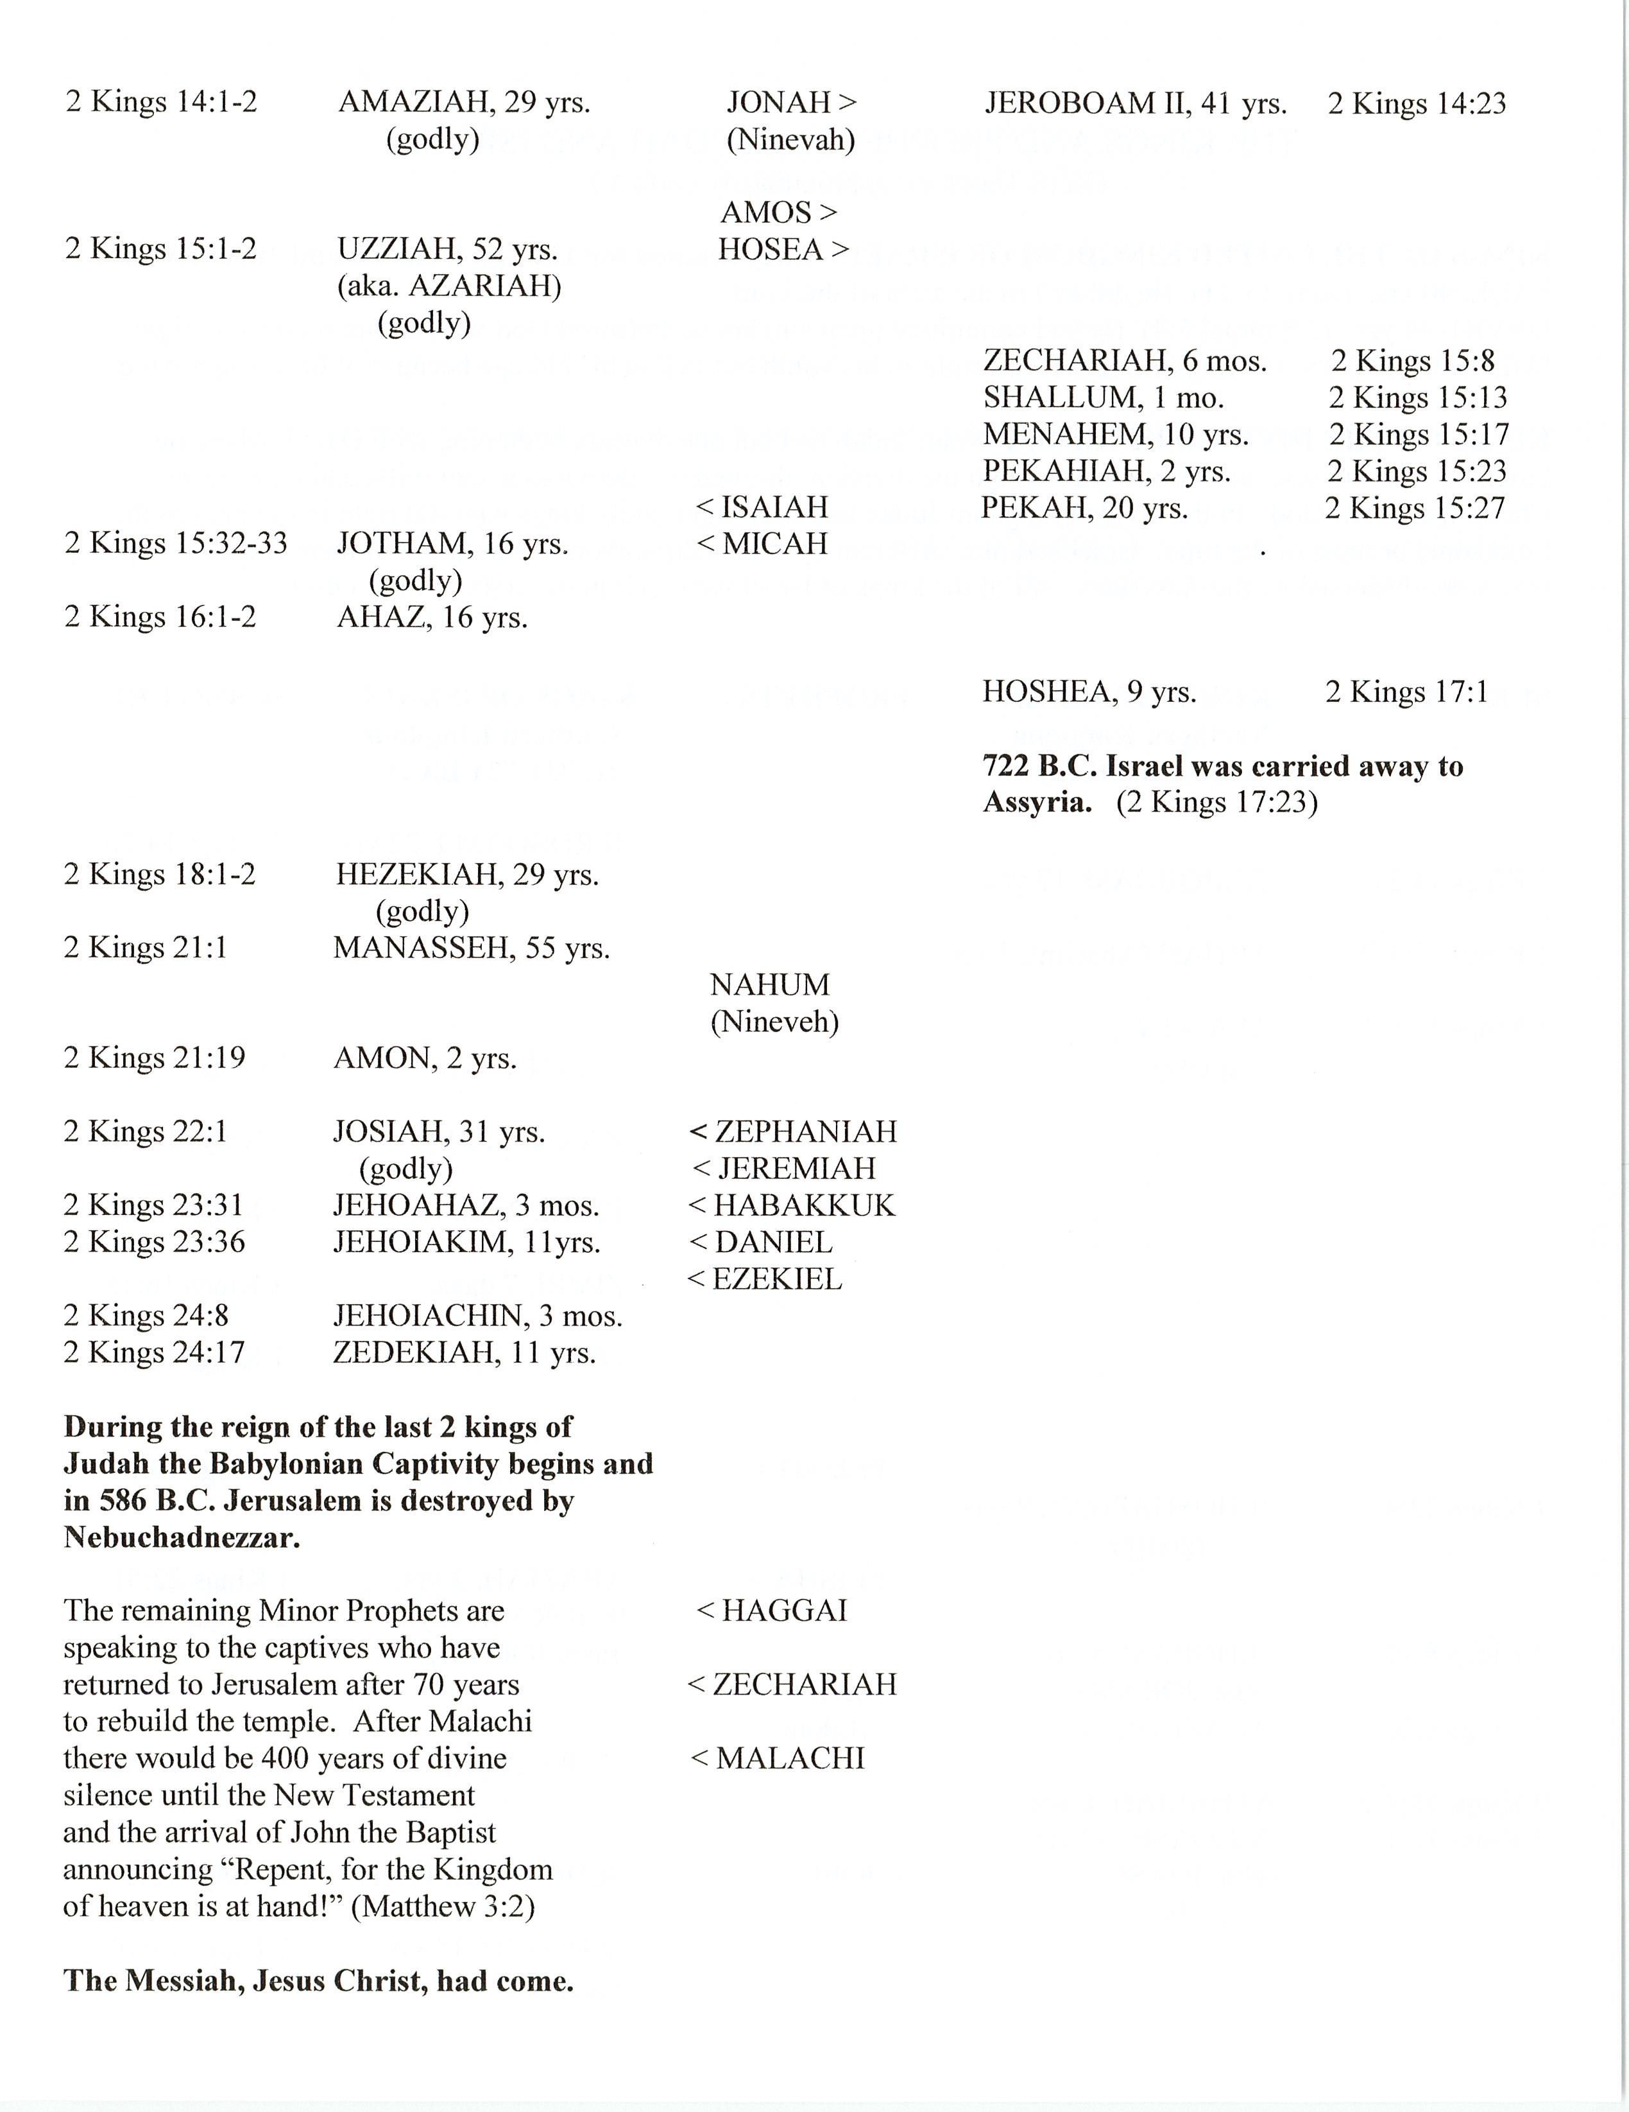

**THE HISTORY OF ISRAEL LESSON 1**

*Remember to cite verses used for your answers. It might also help you to read the questions for the day before doing the reading, so you can note where the answers are as you go along.*

**DAY ONE**

Read 1 Samuel 1

1. a. Describe Hannah’s feelings resulting from her home situation.

HOI

b. What did she do about those feelings?

Answer here

2. Share two different ways Eli responded to her and what we can learn from these.

Answer here

3. a. List the phrases that show Hannah’s confidence in God’s answer to her prayer.

Answer here

b. What great sacrificial promise did she make to God?

Answer here

**DAY TWO**

Read 1 Samuel 2

1. a. Comparing 1 Samuel 2:1-10 with Luke 1:46-55, who echoes Hannah’s song (prayer)?

Answer here

b. Which phrases in 1 Samuel and Luke:

1). Can refer to the Promised Messiah?

Answer here

2). Glorify God?

Answer here

3). Express His eternal purpose?

Answer here

4). Explain how He works?

Answer here

c. PERSONAL: Choose one that was special to you.

Answer here

2. a. Who did Eli honor more than the Lord?

Answer here

b. How?

Answer here

c. What should he have done?

Answer here

d. What prophecy was given in view of this?

Answer here

**DAY THREE**

Read 1 Samuel 3-4

1. List several things about Samuel’s upbringing that are implied and logical in these chapters.

Answer here

“The ark symbolized the presence and power of the Lord. Yet, Israel treated it like a good-luck charm, which would insure them victory over the Philistines. Knowing that victory or defeat depended upon the Lord, they confused the symbol of His presence with His actual presence. In this way, their understanding of God resembled that of the Philistines.”

*NKJV The MacArthur Study Bible* notes

2. a. What did the Israelites do after they were first defeated by the Philistines?

Answer here

b. According to Exodus 25:10-22, briefly describe the “ark of the covenant” and its importance.

Answer here

c. Why would God allow the Philistines to take it?

Answer here

d. How might this apply today?

Answer here

3. List three results of God’s judgment in Eli’s household.

Answer here

**DAY FOUR**

Read 1 Samuel 5-7

1. Give the results of the presence of the ark in Ashdod, Gath, and Ekron.

Answer here

2. How did they return it to the Israelites?

Many think that these tumors were a symptom of a type of bubonic plague brought by rats. This specific trespass offering was the Philistines way of saying that they knew this judgment was from the Lord and they were asking him to take away His anger.

Answer here

3. Why did God judge the people of Beth Shemesh? Also see Numbers 4:20.

Answer here

4. a. Make a list of events that led to victory for Israel.

Answer here

b. How might these kinds of actions bring revival to our country?

Answer here

**DAY FIVE**

Read 1 Samuel 8-10

1. a. What government change did Israel request of Samuel?

Answer here

b. Give their reason.

Answer here

c. How did Samuel respond?

Answer here

d. What did God reveal to Samuel regarding their request?

Answer here

2. List some of the character qualities you see in Samuel in these chapters.

Answer here